**Difference Between UV and RO Water Purifiers**

(RO) Reverse Osmosis and (UV) Ultraviolet are the most common types of Water Purifiers. It is supposed that (RO) Reverse Osmosis is the perfect better than (UV) Ultraviolet. RO Gives the high level of purification while the (UV) purifier is combined with different forms of Filtration as (UV) light kill all the bacteria and any types of viruses.

Here the Biggest question is how to choose the water Purifier? It’s the all depend on your area’s drinking water. If the water in your areas contains more ions so we recommend buying the RO [water](https://bestwaterpurifierdelhi.com/raw-water-is-safe-for-drink/) Purifier.

An RO has in-built total dissolved solids ([TDS](https://bestwaterpurifierdelhi.com/tds-meter/)) control and if inside your water low level of ions then we recommend for a (UV) purifier.

Difference Between the UV and the RO Water Purifiers.

Reverse Osmosis Water Purifier System:

Inside this water Purifier, water is purified using the [RO](https://bestwaterpurifierdelhi.com/advantages-and-disadvantages-of-ro-water-purifier/) technology which is opposite from Osmosis technology. The Impurities like dissolved solids inside the [water](https://bestwaterpurifierdelhi.com/what-happens-if-you-drink-too-much-water/) are removed. But there are approximately fewer chances of reducing the invisible bacteria when compared to the (UV) [water](https://bestwaterpurifierdelhi.com/drink-more-water-can-help-you-to-lose-weight-how/) purifier.

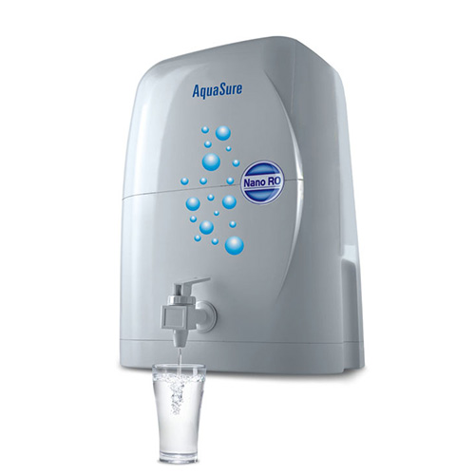

How Does (RO) it Work?:

Inside the (RO), purifier has a membrane that filters to all the dissolved solids and hidden particles like bacteria. It can reduce all types of germ from the water and is, therefore, it is a cleaning process.

The (RO) system gets to remove all the molecules from a zone of high solute concentration a to lower solute concentration through the pressure of incoming [water](https://bestwaterpurifierdelhi.com/do-you-know-which-time-best-for-drink-water/) across the membrane and leave all types of impurities behind.

Osmosis allows all the [water](https://bestwaterpurifierdelhi.com/reasons-to-drink-the-water/) molecules to flow across a semipermeable membrane from a low solute concentration to high solute concentration.

Ultra Violet (UV)  Water Purifier System:

This system work with (UV) rays, where all the germs and all types of microbes are destroyed with the help of (UV) rays and we get pure water. This system can kill all the harmful contaminants and can be combined with the other forms of filtration by reducing chlorine.

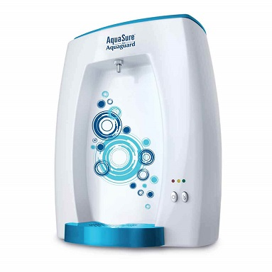

How Does (UV) it Work?:

(UV) water purifier by exposing the (UV) rays get inactive all the diseases which inside the [water](https://bestwaterpurifierdelhi.com/how-much-water-should-you-drink-in-a-day/). It always uses the (UV) light source which is rotated in such as a manner, that when [water](https://bestwaterpurifierdelhi.com/water-therapy-and-its-advantages/) allows passing in a flow exposed the (UV) rays, infiltrate the cells of bacteria and destroy their abilities to reproduce.

After the RO process stage, all the germs are destroyed with the (UV) rays and able to gives the pure drinking [water](https://bestwaterpurifierdelhi.com/eggs-how-improve-the-health/).

It’s Maintenance Costs:



An (RO) gives fully 100% pure [water](https://bestwaterpurifierdelhi.com/reasons-to-drink-the-water/). Which is free of chemical and the smell, it requires always low maintenance cost while at a low cost and quality (RO) compromises on filters and other accessories which needs a high maintenance cost.

The (RO) purifiers need a Periodic service and can enjoy the best service with his best parts that keep the (RO) running a long time in the perfect condition. For the perfect performance, (UV) lamps require yearly replacement.

There is no assurance that after one year the (UV) light will provide sufficient disinfection. The quartz sleeve has no need of replacement but it should be clean many times in the year.

from；<https://bestwaterpurifierdelhi.com/difference-between-uv-and-ro-water-purifiers/>